Information booklet for parents/guardians
ABOUT
• Start-up at Lilleputt
• Lilleputt private family kindergarten
•Practical information

Lilleputt private Familiebarnehage
Welcome to Lilleputt private familiebarnehage

Welcome to Lilleputt private familiebarnehage
The information booklet must provide information about the practical side of being a parent/guardian with a child in nursery school. (www.lilleputt.barnehage.no).

Presentation of Lilleputt private familiebarnehage
Lilleputt Private Family Kindergarten is a small private family kindergarten with space for a maximum of 10 children aged 1-5 years. The nursery is owned and run by Marianne Pettersen. Lilleputt opened on 02.08.2004. The nursery is located in a private home in the center of the Storhaug district. Our nursery is based in a basement, with an area that provides good opportunities for play and learning, and where the group of children can be divided into smaller groups. We offer sleeping outside, and have a separate outdoor play area connected to the nursery. We also use the local area actively in our educational work. Both home and nursery are approved by Stavanger municipality, and follow the same laws and guidelines as an ordinary nursery. The nursery has an owner, a preschool teacher and 2 permanent employees.

The nursery's content and operations are the responsibility of the owner and the preschool teacher, and the other staff receive regular individual guidance and follow-up in general. The nursery is run by a municipal grant and parental payment.

What is familie barnehage::
Family nurseries are small groups of a maximum of 10 children aged 1-5 years who live in private homes.

We at Lilleputt Private Family Kindergarten are concerned that we meet children and parents with trust and respect. Our aim is for the nursery to contribute to well-being, joy, development and learning. We are here to ensure that the children have a safe and developing everyday life, where we create space for play, life expression and meaningful experiences and activities. Our kindergarten must be a safe place that is based on community and friendship in a developing learning environment. With a small children's group, it is easy to take into account each child's individual needs, and the children will experience a high degree of predictability and have a number of adults to deal with
Our vision is: Assertiveness
Wait for turn Social competence.
Community
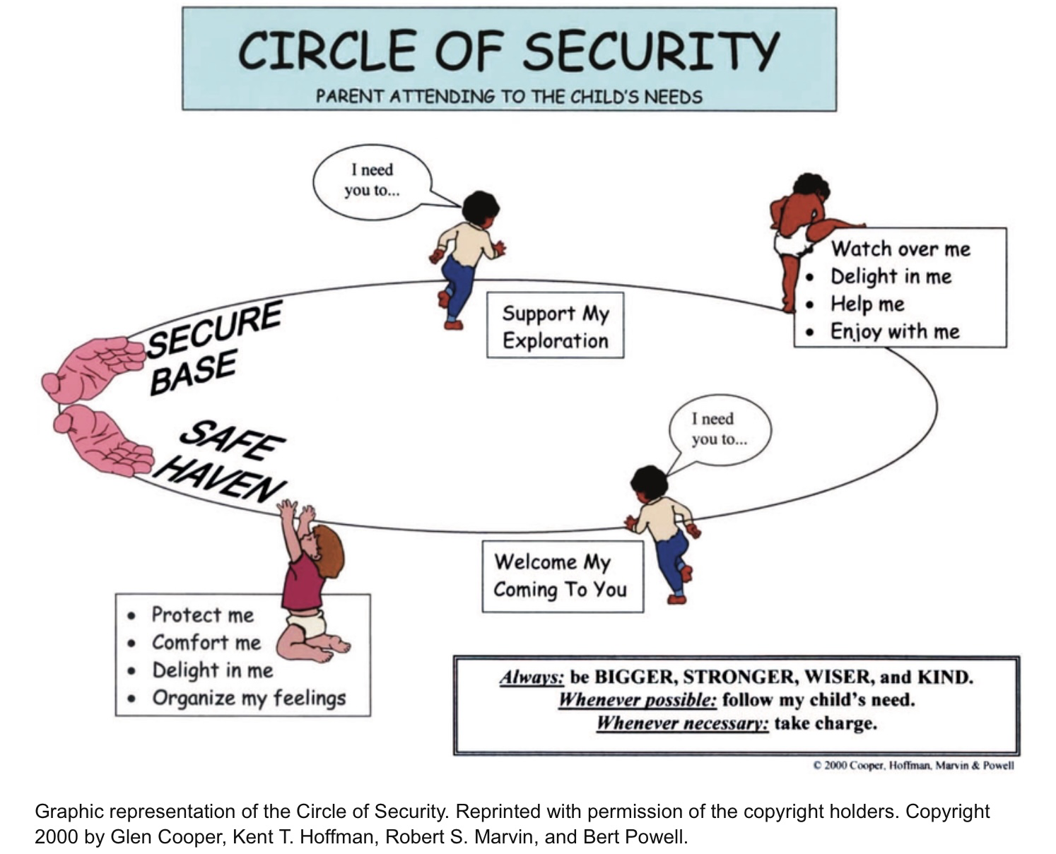

Start in kindergarten
When a child starts kindergarten, it may be the first time the parents hand over part of the care and responsibility to others. It is important that parents/guardians feel safe.

In order to achieve a good and safe start for both children and parents, we spend a lot of time on the start.
For children under the age of 3, we have an adaptation period of at least five days.
For children over the age of three, we have 1-3 days of getting used to them, depending on the child's needs and by agreement with the parents.
We want all new parents to take the time to spend some time in the ward, to get to know the other children, routines and staff.
Unfortunately, all the children cannot start on 15 August. But all must have started by September 1.

How long the child needs to become safe depends on the child's personality, age and previous experiences. During this period, each child often needs a lot of contact with adults, and will be given a contact person, i.e. an adult who has special responsibility for the child and contact with the parents
No two children/parents are the same and therefore it is impossible to give advice that suits everyone, but we want each child and parent couple to be met based on their needs. Having some familiar things in the nursery often makes the start better for the child. Therefore, it can be good for the children if you bring pictures of the family and things that are safe for the child, such as cloth or stuffed animals.

- At the start, parents are present with the child for a minimum of five days
- The parents actively participate in practical tasks in the nursery, and have the main responsibility for the child in play, care and meals
- The contact person from the nursery is nearby and gradually approaches the child.

Day 1
- Contact person: When you arrive at the nursery, you will be welcomed by the child's contact person. The contact person's task is, among other things, to take extra care of and get to know the child, so that the child is safe and can achieve attachment to him. We want to create a base for closeness and secure relationships between the contact person and the child. This is especially important in the early days, but also later on. When the need for connection is met, the child can move on to exploration and play. It is also important that you and the bar eventually get to know the other adults, so that it does not become so vulnerable if the contact person is away from work.
We use the safety circle actively in this work
- Bring:
- Slippers or slip-on socks
- Change of clothes
- Outdoor clothing
- Diapers
- Something familiar and safe for the child: pacifier, cloth or stuffed animal
- Picture/photo of you parents/guardians, others with whom the child is connected (approx. 5). You will be given a heart where you will stick these on. The house is being laminated, and will be used in the nursery. This house can be of great help to the children when they get bored and miss their mother and father.

Day 1-3:
- Parents/guardians:
- Have primary responsibility for the child
- Be available and close to the child at all times. This also applies to children who quickly get to know each other in the nursery
- Actively participate in the day-to-day life of the kindergarten
- Get information about how the daily rhythm in the nursery works
- Get to know the staff.

- Contact person:
- Be nearby to get to know the child and have the opportunity to observe him
- See the child together with his parents. It provides information about, among other things, the child's habits and ways of communicating, and this information will later contribute to making the child's everyday life in the nursery better.
- Get to know the child's needs and inform about the nursery's routines and content.

Day 4-5:
- Parents/guardians leave the child for a short while so that the child can be alone with the contact person.
- How long you will be away is agreed in advance, but always be available so that the nursery can easily get in touch.

The first weeks:
- Pick up the children early, so that the child does not have such long days. This is in the best interests of the children. Once attachment has been established, it is intended that the attachment person should act as a safe base for the child.
- The child may have a reaction two or three weeks after starting when they understand that HERE they should actually be.
- It is important that you always tell the child that you are leaving, and do not drag out the farewell for too long. In this way, the child gains trust in you. The child knows that you are leaving, but also that you are coming back. It creates predictability for the child. That the child sees that the parents are confident in the adults in the nursery can make it easier to accept that the parents are leaving the nursery
- • The contact person will confirm the child's feelings and comfort the child, telling them that you will return. You are welcome to call/text and ask how things are going if you are worried.
- If the child cries when you pick them up, it may mean that they are not completely safe in the nursery yet. They hold their feelings until you come. There can be sad feelings, but also joy.
- Many impressions must be processed for the children. Some may sleep restlessly at night, or more than usual, some change their eating habits, and some may get a bit of a stomach ache. This is the child's way of saying that they are not completely comfortable and safe in the new situation. Usually this passes quickly. Some children will need more time in the start-up phase, but others need less time. It is nice if you have the opportunity to adjust the length of your stay in the nursery according to the child's needs.
- • The start-up is often short and hectic. The staff must get to know many children and parents in a short time. There can be a lot of information for children, parents and staff to digest. We hope that everyone understands this, so that the period will be positive for all parties. It may be a good idea to plan for quiet afternoons at home without activities in the start-up phase. Investing in time and good relationships with new children and parents will have a positive ripple effect for both the child in relation to learning and development, and not least for further parental cooperation. This will lead to increased qualities on offer to the child

Practical information

Opening hours
The nursery's opening hours are from 7.30 a.m. to 4.30 p.m. The door may be open before 7.30, but then you will wait outside in the changing room until 7.30. At 4.20 p.m., the children who are still in the nursery will meet in the changing room. The staff's working hours are identical to the opening hours, i.e. our working hours last until 16.30. The last few minutes before closing time are used for closing procedures and we are therefore very happy if you collect your child a little earlier so that we can resolve when the time is 4.30pm

The start of the day
Undress the child in the cloakroom and follow the child inside. Parents are responsible for order in the wardrobe and labeling of all clothes.
The children must bring enough clothes to the nursery. There should always be one or two changes of clean clothes in the nursery. The weather changes quickly, so it is best to have rain gear and boots are available every day (you may want to have a set of these in the nursery). It is easy for clothes to disappear/be put on the wrong shelf. To find these, you must mark or write names in the children's clothes. One is a box where we collect nameless clothes. There you can find clothes you might miss

We do not wear outdoor shoes inside. The child therefore has indoor shoes or slippers. These are kept in the wardrobe
Parents must take off their shoes when entering the nursery.
We prefer that the children do not bring toys from home. The employees cannot take responsibility if brought toys and books are destroyed or disappear

Diapers are brought along, parents/guardians are informed at the kid level when new nappies are needed in the nursery

Food and meals. We have healthy food in the nursery. There is no occasion to bring biscuits, sweet yoghurts or the like. The children are served breakfast, lunch and a fruit meal, so they do not need to bring their own food to the nursery. You will be charged food money on your monthly invoice. As of today, it is NOK 300 a month. If the children are to eat breakfast, they must arrive at 8.30. We try to be finished by 8.45

Sleeping. We want the children to sleep outside. We have prams and sleeping bags. You bring a pacifier, teddy bear, cuddly rag or similar.
It is the egg's responsibility to have wagons standing here overnight

Outdoor play - and activities outside
We have a strong focus on safety outside. All guardians must remember to engage the safety lock on the gate. When we go for a walk, everyone wears a reflective vest. We are out in all kinds of weather, and it is therefore important that the children have good clothes and that they wear clothes that you are not afraid of.

Information
If there is anything you are wondering or want to ask about, just call or send an e-mail. We post information on the board at Kidplan. In addition, we have a notice board in the cloakroom.

Illness and absence
Call or send an SMS to the nursery no later than 9.30 to let them know if the child does not come to the nursery, so we don't have to wait for children who don't come.

When the child is sick, he must stay at home. When the children are ill, they need rest, while at the same time we want to avoid infection to the other children. This applies in the event of a reduced general condition, such as fever, communicable disease, influenza, corona and other infectious diseases. In the case of vomiting and diarrhoea, the child must be kept at home 48 hours after the last outbreak due to the risk of infection. If the child must have medication, the parents must provide this, the kindergarten does not provide medication.

Holiday
The kindergarten is closed in July, between Christmas and New Year and half days.

Planning days
The kindergarten is closed due to planning days. These can be found in the annual calendar which can be found on the website. www.lilleputt.barnehage.no.

